Miranda L. Jacobs
Fall 2019
Dr. Jo Williamson
Summer 2018
Using Technology to Provide Engaging Assessments in the Classroom

Purpose/Framework

The purpose of the capstone project was to assist WCLC teachers in using Google Suites for Education to assess students’ knowledge effectively. Integrating technology to provide multiple forms of assessment has many benefits in enhancing student learning. In a survey conducted by Kumar and Daniel (2016), they found that almost all respondents reported that the use of technology makes their work easier. Some indicated that employing technology in teaching can help them effectively manage their time, and a significant number mentioned that they have been using technologies in teaching and that the utilization of technology for teaching helps engage students. Overall, results suggested that respondents strongly valued the contribution of learning technologies in enhancing student learning. Respondents who are already currently employing learning technologies in their teaching said they use them for creativity, to facilitate students’ learning, to meet specific learning objectives, and to perform academic tasks.
Therefore, the solution was for WCLC teachers to use Google Suites for Education as a platform to create various forms of assessments appropriate to students learning ability levels. All teachers and students at WCLC have a Google Account that they can use daily. However, some teachers were reluctant users, and some were brand new users for Google Suites. In a study conducted by Coyne, Lane, Nickson, Hollas, and Potter (2017), they found that it was essential to assess participants’ preparedness in using technology in the classroom. Data analysis indicated room for improvement with how prepared participants felt to incorporate technology in their instruction in the K–12 classrooms. Also, there were similar results with how prepared they felt to provide opportunities for K–12 students to use technology in their learning.
Key Events/Documented Strategies
To help make the adoption and transition to using Google Suites easier; there was quality professional learning communities (PLC) that was centered on Google Suites to prepare teachers to use this platform to create student assessments. Teachers learned how to use Google Classroom, Forms, Docs, and Slides during the provided training for evaluations. Admiraal, Louws, Lockhorst, Paas, Buynsters, Cviko, and Kester (2017) conducted a research of teacher’s level of comfort using technology and found that professional development activities of the group of teachers who are uncomfortable with technology can be supported by connecting these teachers to other teachers with higher comfort levels of technology and challenge them to experiment with peer or team teaching with these colleagues. Also, by changing their school environment into a more technology-oriented setting.
In a research PLC group conducted by Thoma, Hutchison, Johnson, and Stromer (2017), they found that teachers were able to use what they learned in PLC to overcome barriers of integrating technology in the classroom and it also helped change their mind about the use of technology in the classroom. Once teachers at Ware County Learning Center had quality professional learning that is centered on the use of Google Suites for assessments, they will buy into using technology effectively to assess students to benefit learning. In an investigation by Chien, Wu, and Hsu (2014), they found that teachers considered the use of technology, not only from their perspective but from students’ point of view also; after learning about the positive effects the use of technology have on instruction and assessments for student learning. The teachers thought about the benefits of using technology in the classroom and found that it was useful and effective for teaching and learning.
During the duration of the capstone project, it did not go as planned. All the teachers did not participate in the project. Two teachers needed help with using Google Suites for Education during instructional time. Both teachers were taught how to use Google Slides, Google Docs, and Google Forms. Only one of the teachers were interested in using Google Classroom. The goal of the capstone project was to conduct workshops to increase the use of Google Suites in the classroom so that teachers can use these platforms to assess students. The tentative schedule for the capstone initially began with conducting professional learning for teachers on the use of Google Classroom. The next workshop should have covered the use of Google Docs and Google Slides. The last workshop was to include Google Forms.
Deliverables
The tentative schedule listed the first workshop in February 2019, but it was in January 2019. Before the first workshop, the teachers were conferenced with, and it was determined that the first workshop needed to cover Google Docs and Google Forms. During the workshop, the facilitator demonstrated to the teachers’ steps of using Google Docs and Google Forms on the SmartBoard. The teachers’ participating in the seminar were provided instructional materials to use as future references when using Google Docs and Google Forms on their own. The facilitator also offered examples of how Google Docs and Google Forms could be used for assessments and during instruction. Before the workshop, the professional learning facilitator asked the teachers to complete a survey. The survey asked the teachers about their comfort level when using Google Docs and Google Forms. Both teachers were not at all competent. The teachers thought that their students had somewhat of a comfort level with using Google Docs and Forms. The teachers believed that the most important benefit for using Google Docs and Forms in the classroom was students use of the digital resource to take notes of the lessons. After the workshop, the teachers completed a survey reflecting on their learning experience. One teacher felt very competent in using those resources for instruction and assessments after the workshop and did not need further guidance from the workshop facilitator. The other teacher, comfort level increased, but still required additional assistance from the facilitator. However, both teachers were willing to use Google Docs and Forms with their students. The teachers reflected on how they would use Google Docs and Forms, and both answered for projects, reports, tickets out the door, pretests, and quizzes.
The next workshop was in February over Google Classroom. Only one teacher attended this workshop over the use of Google Classroom demonstrated on the SmartBoard. The facilitator demonstrated to the teacher how to set up a class in Google Classroom, and how to allow students to join the class by sharing the class code with students. Also, the teacher learned how to add other teachers as collaborators within their Google Classroom. The facilitator showed the teacher how to add student’s classwork to the classroom and how students can submit their work. It was demonstrated to the teacher how to add links to Google Classroom and attachments for students to complete assignments, quizzes, and other forms of assessments. Before the workshop, the teacher completed a survey for the facilitator. While completing the survey, the teacher stated that she was not competent in using Google Classroom. After the workshop, the teacher was excited to use Google Classroom and said that she would use it daily in her classroom.
The last professional development covered the use of Google Slides. This workshop took placed in March. During this workshop, the teachers learned how to create a basic slide presentation using Google Slides. The teachers were provided with examples of using Google Slides for student instruction and assessments. The teachers were provided with materials to use for later reference. Teachers stated that the students would use Google Slides in their classrooms to complete projects, that are a form of student’s assessments. Before the training, the teachers were not comfortable with using Google Slides. After the workshop, the teachers were more satisfied with using Google Slides. The teachers were excited that they could teach their students how to use Google Slides to complete and share their projects with the class. The teachers were shown how students could share their slide presentation with them for grading.
Surveys/Outcomes
Initially, the facilitator stated that she would make a Weebly website to house the instructional material for the teachers to reference when needed after the workshop. However, the facilitator enjoyed using Google Classroom and thought it would be an excellent idea to store all the workshops instructional material within the classroom. The facilitator did not make a classroom for the instructional material until all workshops were finished. For evidence of teachers using Google Forms, Docs, Slides, and Classroom, they showed some of their student’s submissions of projects with Google Slides and Google Docs. One of the teachers added me as a collaborator on her Google Form. Since one teacher only used the Google Classroom, the workshop facilitator was able to observe the teacher using Google Classroom. After the workshops were completed, the teachers were asked to provide the professional learning facilitator with feedback on how the workshops could improve in the future with other teachers. The teachers stated that the facilitator should allow each person to give a presentation over Google Forms, Docs, Slides, and Classrooms. Also, it was suggested that the facilitator create an instructional video showing necessary steps of using Google Forms, Docs, Classroom, and Slides for teachers to reference when needed.
Overall, the capstone project went well, although the tentative schedule did not go as planned. The timing was adjusted to help meet the teachers needs as they wanted to incorporate the Google Tools in their classrooms. The implementation of the project deviated from the proposal because of the scheduling. The last workshop was set in April, but that is a busy month and moved to March. The school spring break is in April and upon returning from Spring break is review time for the Georgia Milestones assessment. The deviation of the schedule worked well because the teachers were able to use some to the Google Tools to help students review. The follow-up plans for the project were to have the workshop facilitator observe the teachers using Google Suites for Education in their classroom. One teacher did not need any more follow-up instruction after attending the workshops. However, the facilitator continued to assist the other teacher after the workshops.
In closing, the capstone project implementation process can use some improvement for future workshops. The facilitator will work on creating instructional videos to upload to the Google Classroom built for the teachers. The teachers can refer to the videos anytime they would like. The new plans will include instructional videos. Also, the new plan will consist of teachers demonstrating how to use the Google resource being covered during the training at the end of the workshop before dismissing.
Discussion and/or Reflection

From the completion of this capstone, there was a lot learned about technology facilitation and leadership. It was a lot of planning, researching, and deliveries that went into completing the capstone experience. However, the Instructional Technology Department emphasizes on identifying a problem or need, strategic plan to meet the demand, gathering data, and reflection. Within the program, the contenders mastered professional technology standards that would help become efficient technology facilitators and leaders within their school. The capstone project exhibited the mastery of the technology leaders’ standards by stating a problem or need that the potential technology leader saw in their school. After reporting the need, the technology leader designed, developed, and implemented a capstone proposal that solved the school need for more technology-infused assessments in the classroom. With the implementation of professional learnings and workshops over using Google Suites for Education for informal and formal assessments in the school, teachers helped contribute to their school improvement and student learning outcomes.
Designing, planning, and implementing a valuable workshop that will meet the needs of teachers have various barriers, some including budgets and common planning time. This program has assisted the candidates with understanding how to overcome those hurdles and to plan and implement professional learning to support teachers in their profession. Since education has taken a turn to involve more technology for instruction and learning to produce 21st Century Learners, it is essential to help teachers become fluent with using technology resources and tools for student learning. The initial goal for the capstone project was to begin the workshops in February, but the school hired a new teacher that did not have any prior knowledge of using Google Suites for instruction, learning, and assessments. The projected conclusion date for the project was scheduled for April but was moved to March. The planning of the workshops required a lot of planning, research, and evaluating colleagues. It is critical to understand things do not go as planned, even with schedules. By having a new teacher, it was great to work with someone who has never used Google Suites.
While working with the new teacher, it made some resourceful workshop sessions. Not only working with the new teacher, but also a teacher that needed help with implementing Google Suites effectively in the classroom for assessments, instruction, and learning. The initial proposal plan was to assist teachers in implementing Google Docs, Forms, Classroom, and Slides for student assessments. After conferencing with the two teachers, and providing surveys, the teachers were also provided with suggestions of ways to use Google Suites for student assignments and instruction, not only for assessments.
As a technology facilitator and leader, it is imperative to have excellent communication skills with colleagues. This program and the completion of the capstone project, helped the technology facilitator become more a proficient communicator and leader. Although obstacles were faced, such as issues with times and scheduling of dates, it is crucial to have communication with colleagues and provide and receive feedback.
The pre-survey and post-workshop surveys provided valuable feedback to the professional learning facilitator. There are various recommendations for other professionals attempting to plan, design, and implement a set of workshops to teach educators how to successfully implement Google Suites for Education into instruction for practical student assessments. First, be open to change. Understand that the allotted time and schedule planned is tentative and may need to change. Secondly, it is imperative to have patience, communication skills, and listen while conducting training. Thirdly, provide colleagues with appropriate technology tools that can be used during training to follow along and try the different features while the facilitator is making the presentation. In addition to providing technology devices, record the workshops, and store the recordings using a free Web 2.0 tool that the participants can quickly assess for future references. As a post-workshop assignment, have at least one participant make a presentation of how he or she implemented the newly learned initiative in their classroom. Lastly, plan each workshop thoroughly. For example, the first workshop could cover the use of Google Slides. Begin the first workshop for Google Slides as if every partaker is a beginner user. As part of the follow-up plan, incorporate a continual workshop, and include features for intermediate or proficient users. By breaking the workshop into different sessions, this does not overload the participants with a lot of information at once.
The recommendations, coursework, professional standards, and field experiences in the Instructional Technology Specialist Program provides technology facilitator and leaders with the needed skills, knowledge, and dispositions needed to become successful teacher leaders that work and communicate with their colleagues to aid with the implementation of research-based strategies, technology resources and tools to help the school improvement and student academic success.

References

Admiraal, W., Louws, M., Lockhorst, D., Paas, T., Buynsters, M., Cviko, A., & Kester, L. (2017). Teachers in school-based technology innovations: A typology of their beliefs on teaching and technology. Computers & Education, 11457-68. doi:
10.1016/j.compedu.2017.06.013

Chien, S., Wu, H., & Hsu, Y. (2014). Research Report: An investigation of teachers’ beliefs and their use of technology-based assessments. Computers in Human Behavior, 31198-210. doi: 10.1016/j.chb.2013.10.037

Coyne, J., Lane, M., Nickson, L., Hollas, T., & Potter, J. P. (2017). Assessing Pre- Service Teachers’ Attitudes and Self-Efficacy in Using Technology in the Classroom. Teacher Education and Practice, (4), 637.

Kumar, S., & Daniel, B. (2016). Integration of learning technologies into teaching within Fijian Polytechnic Institutions. International Journal of Educational Technology in Higher Education, 13(1), 1–17.

Thoma, J., Hutchison, A., Johnson, D., Johnson, K., & Stromer, E. (2017). Planning for Technology Integration in a Professional Learning Community. Reading Teacher, 71(2), 167-175.doi:10.1002/trtr.1604

Appendix A
Pre-Workshop Survey

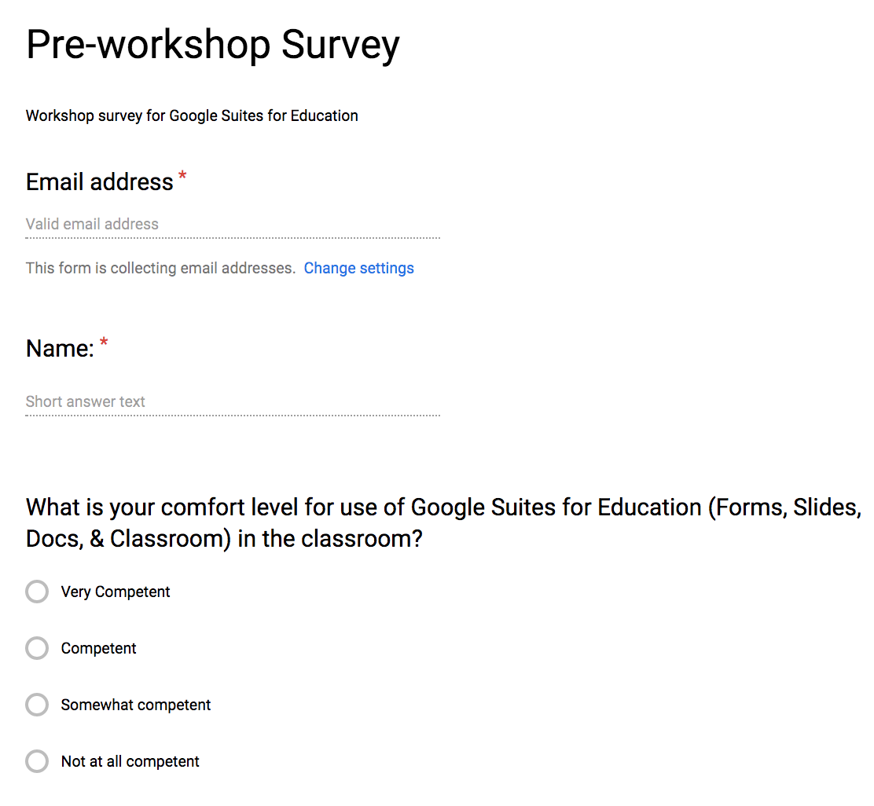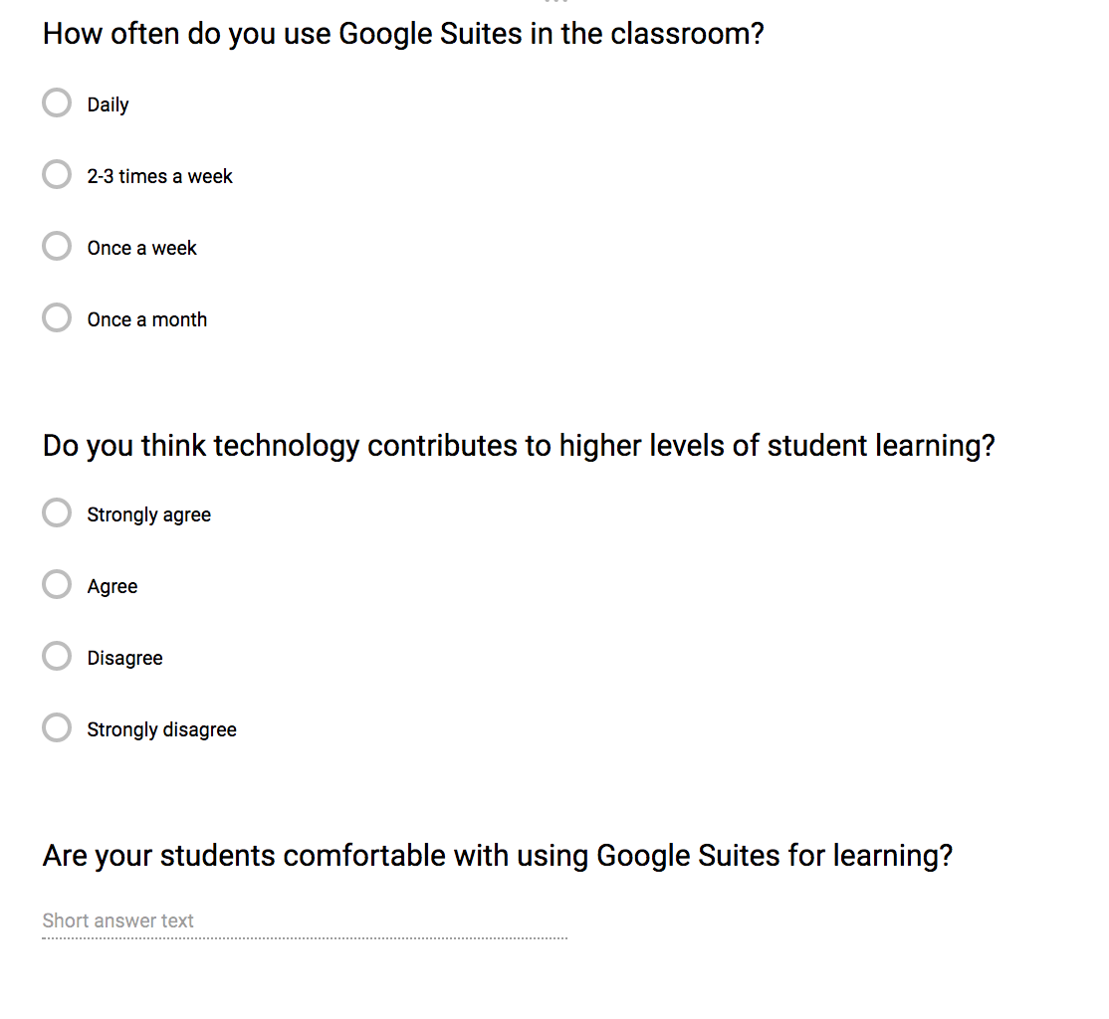

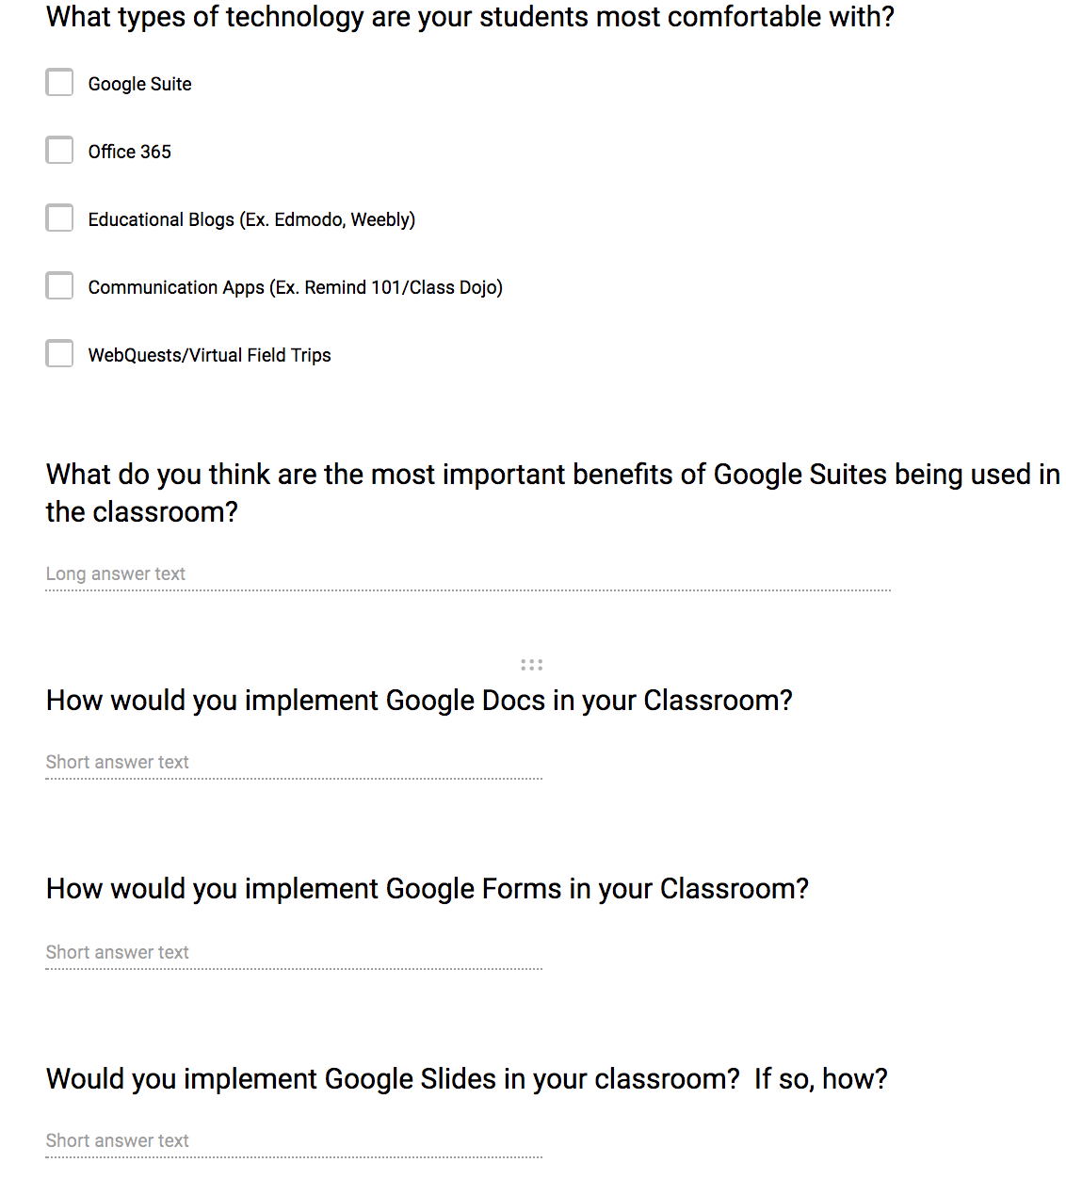
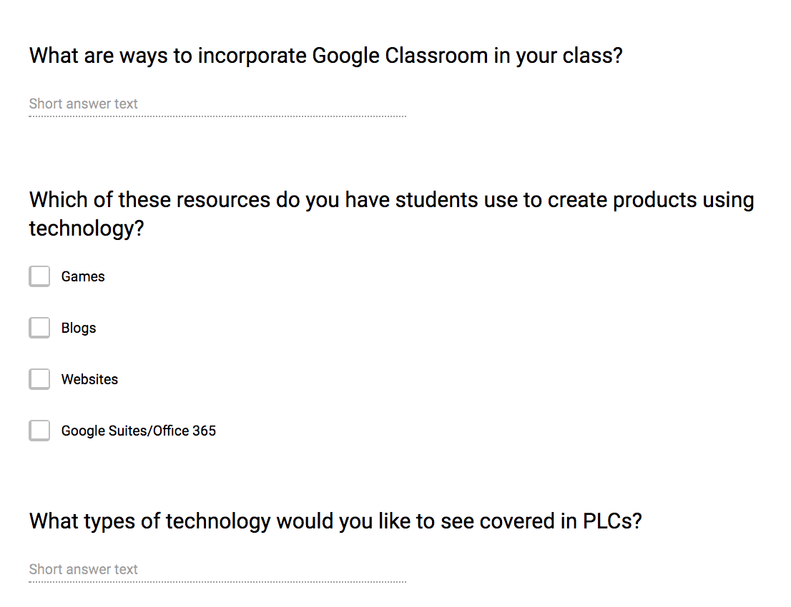

Appendix B
Pre-Workshop Survey Results
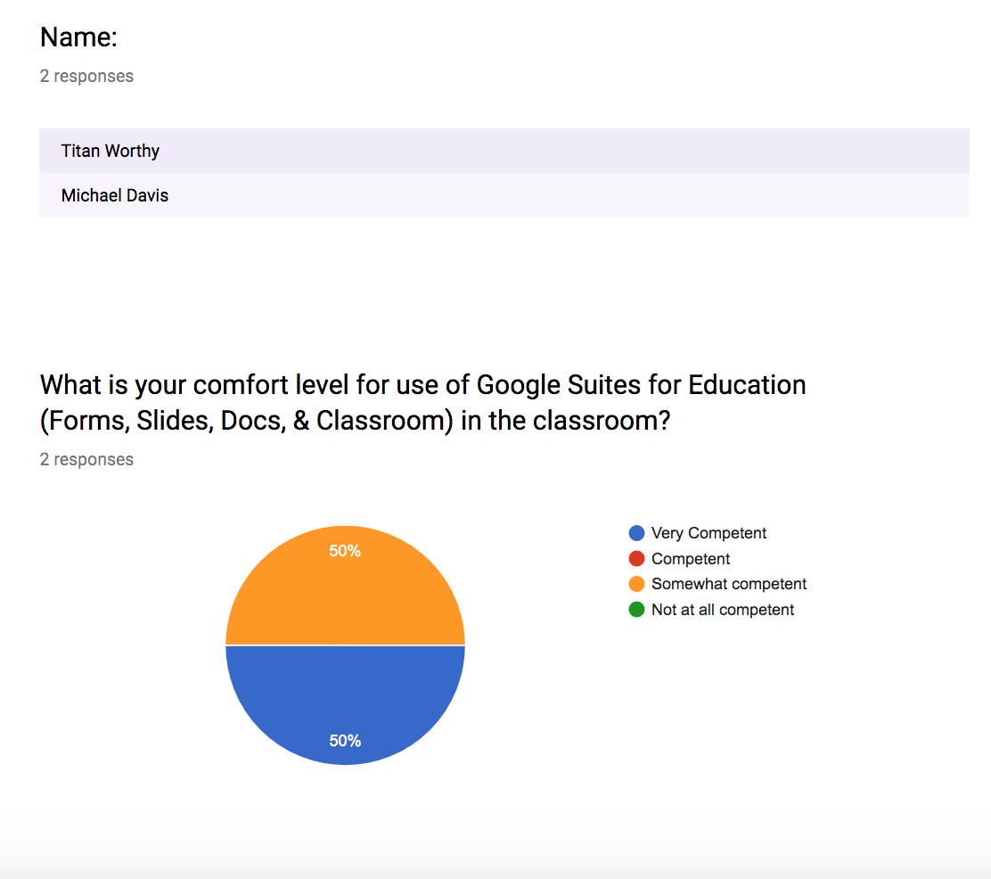
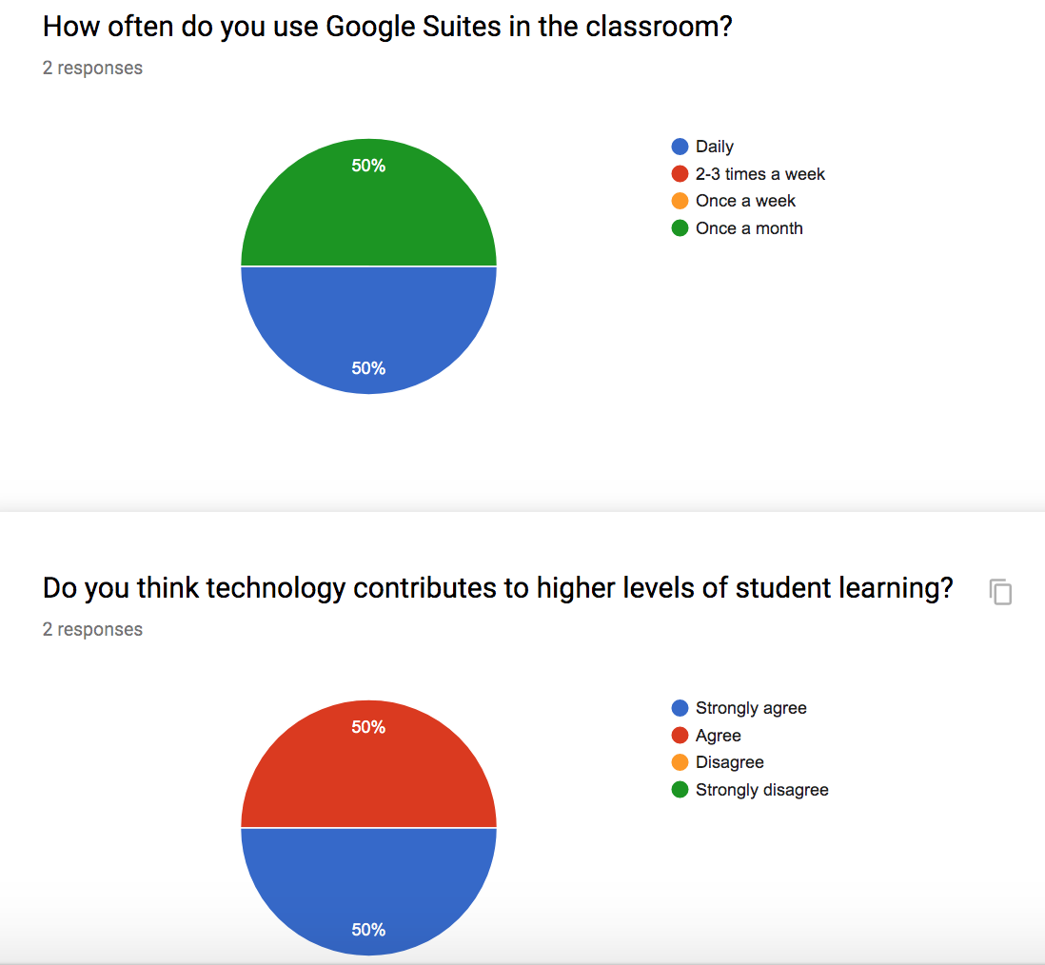
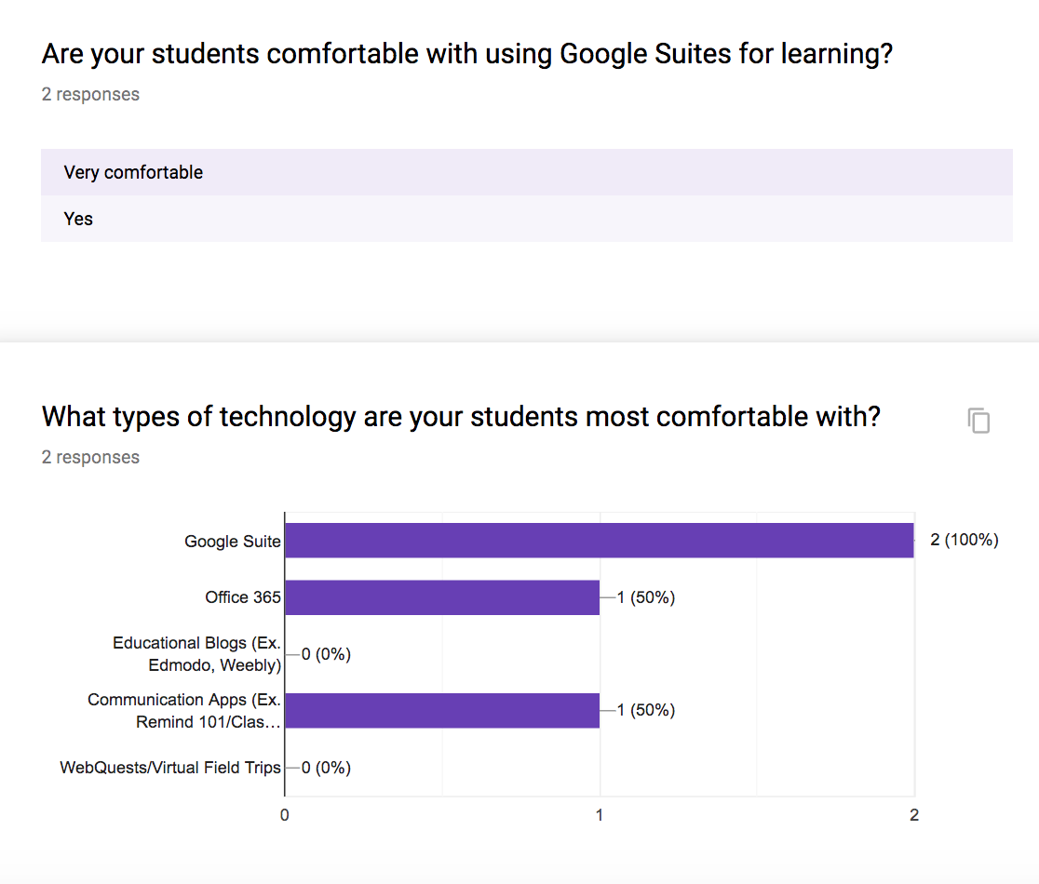
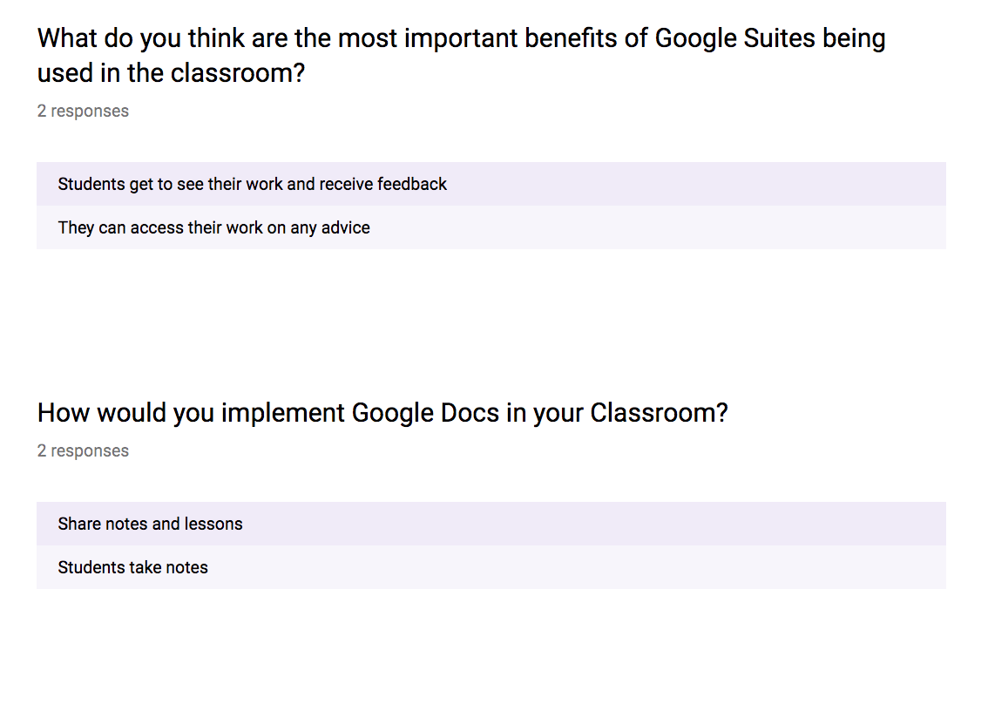
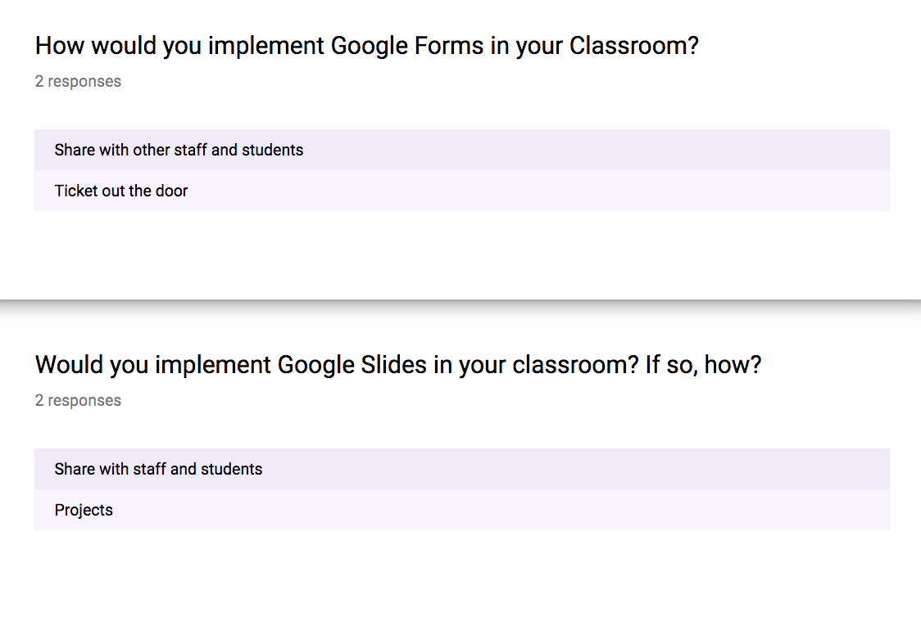
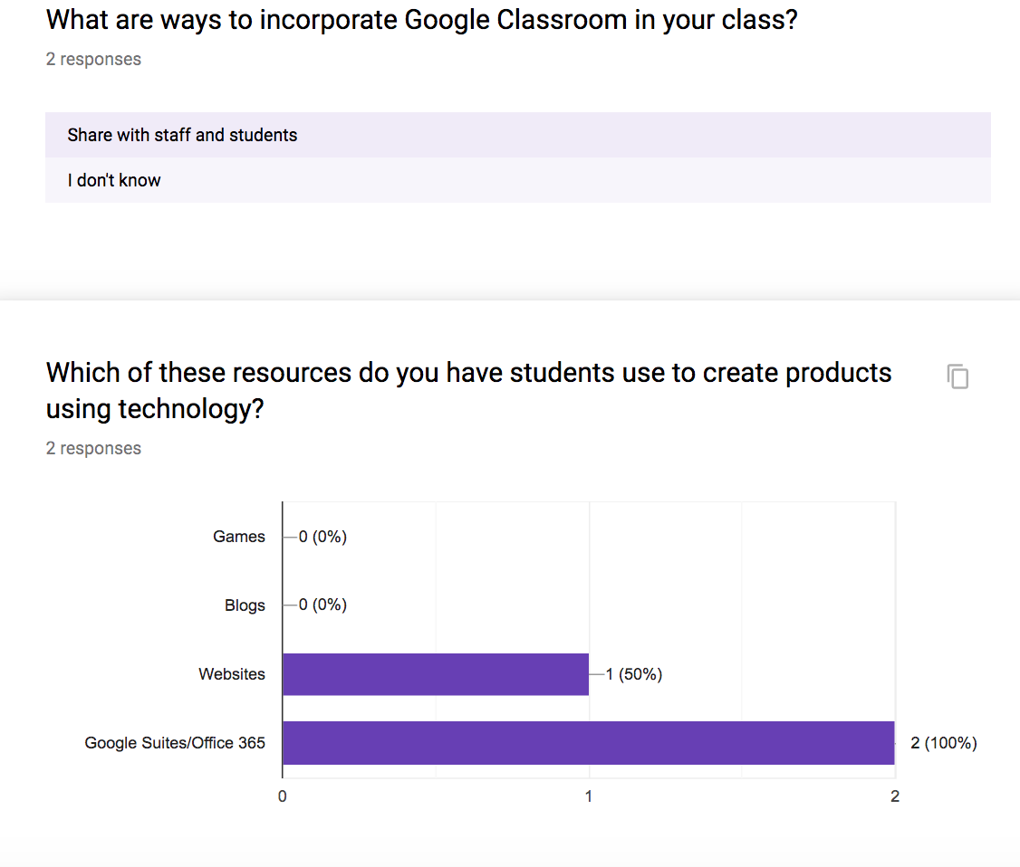
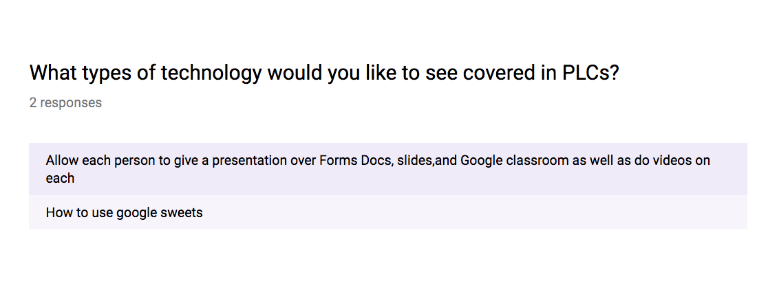

Appendix C
Workshop 1: Google Docs & Forms

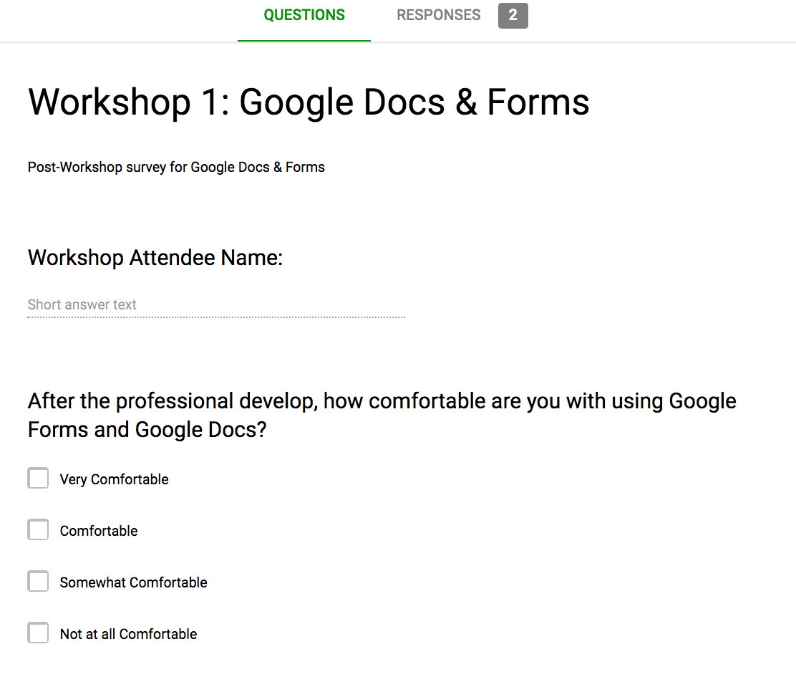
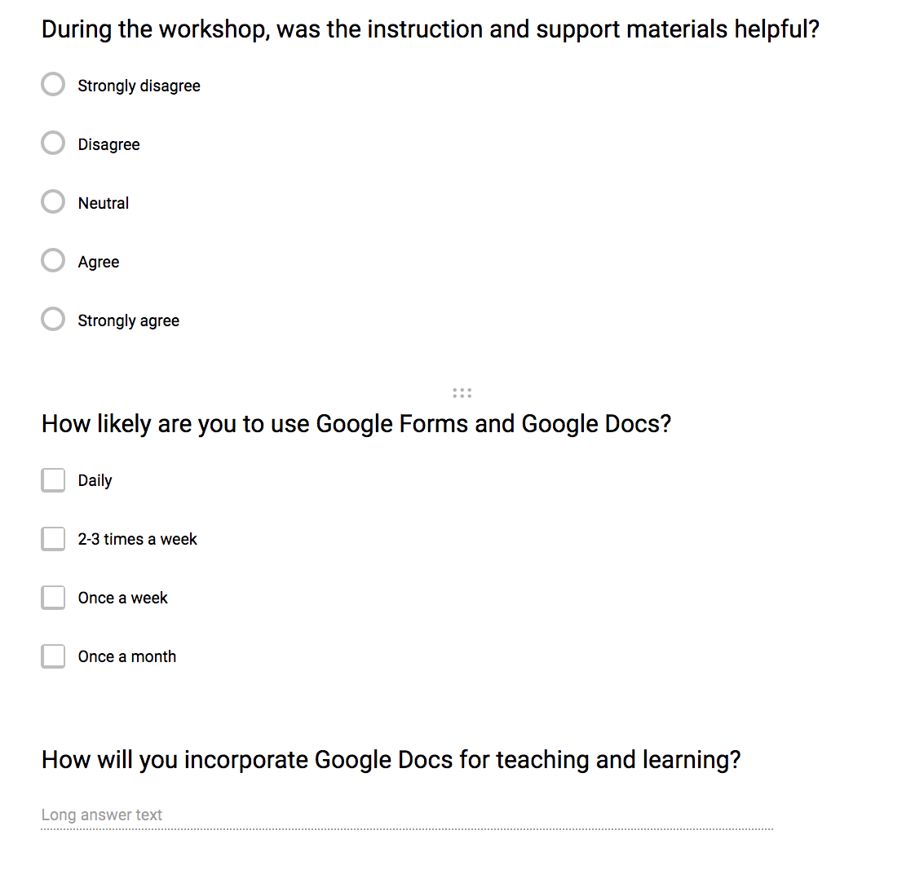
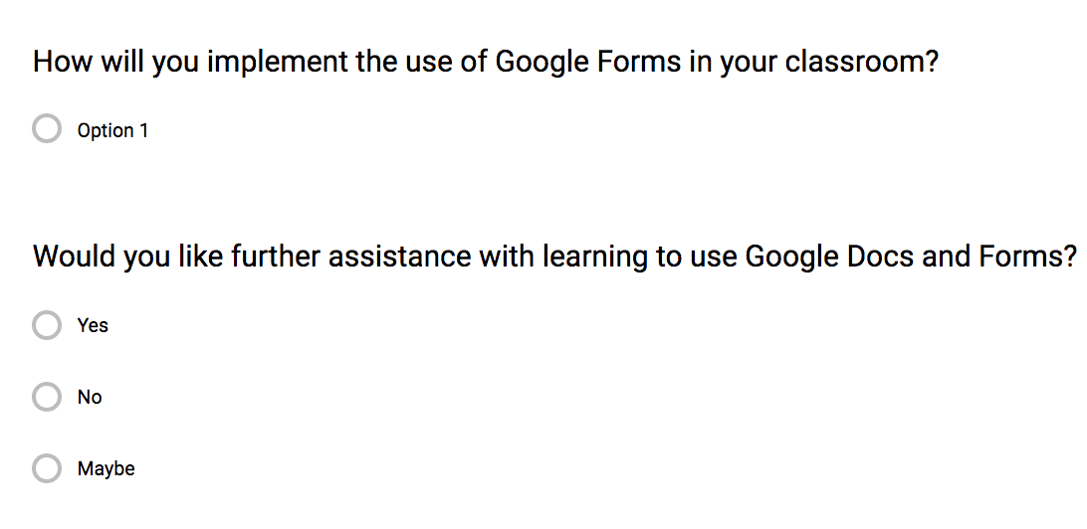

Appendix D
Workshop 1: Google Docs & Forms Responses

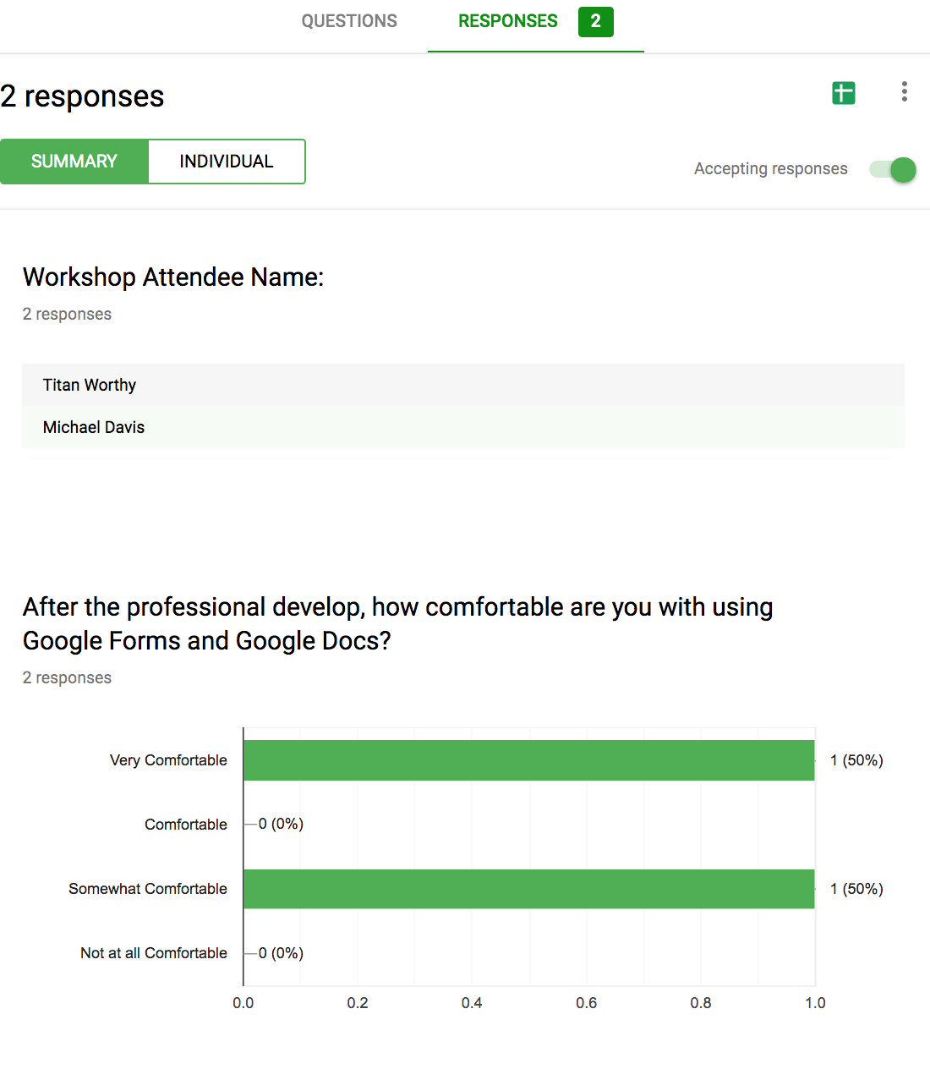
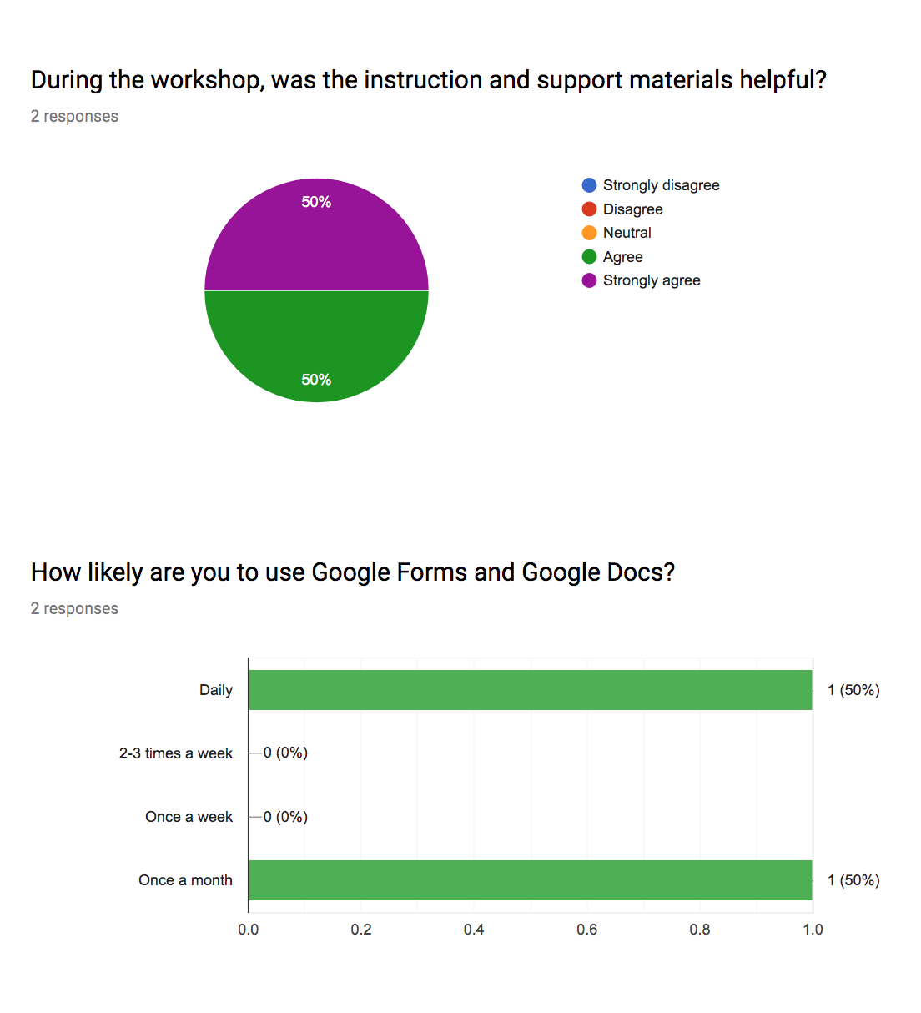
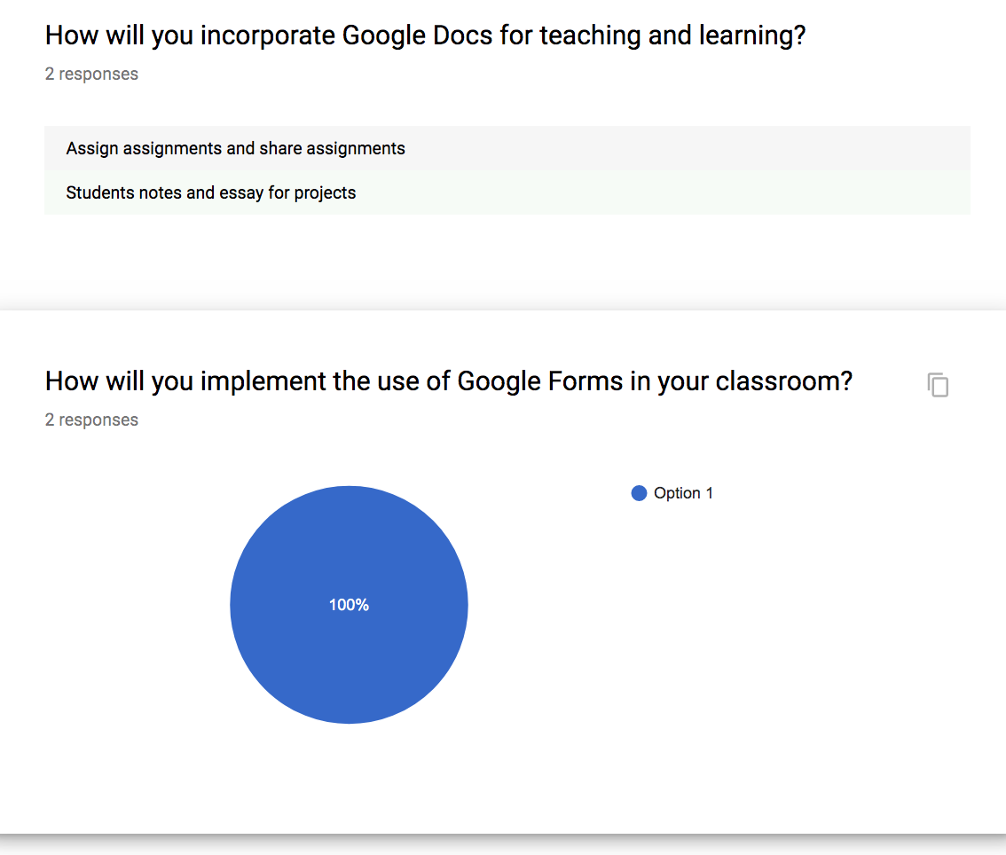
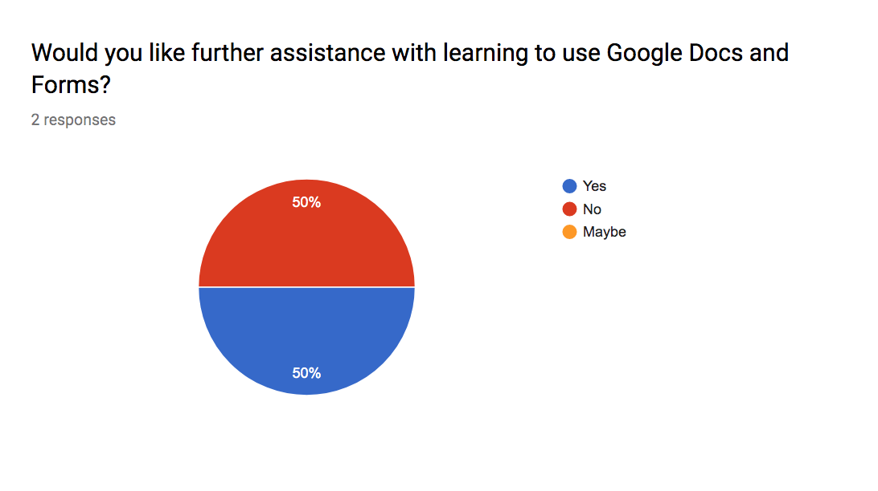

Appendix E
Workshop 2: Google Classroom

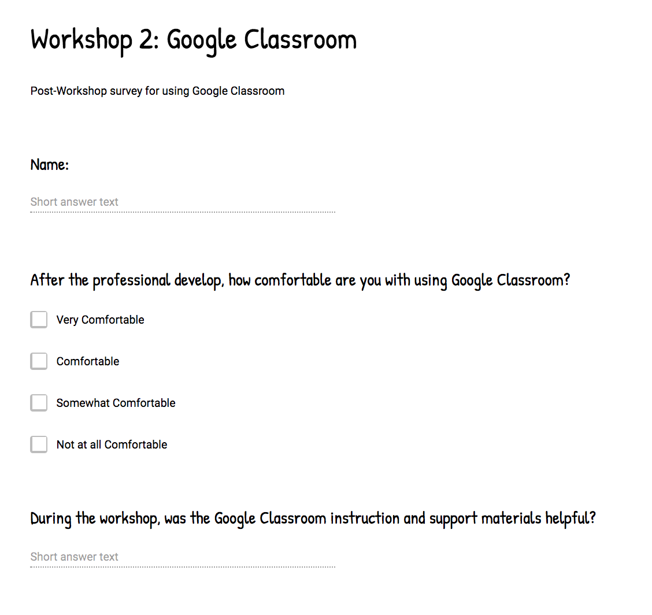
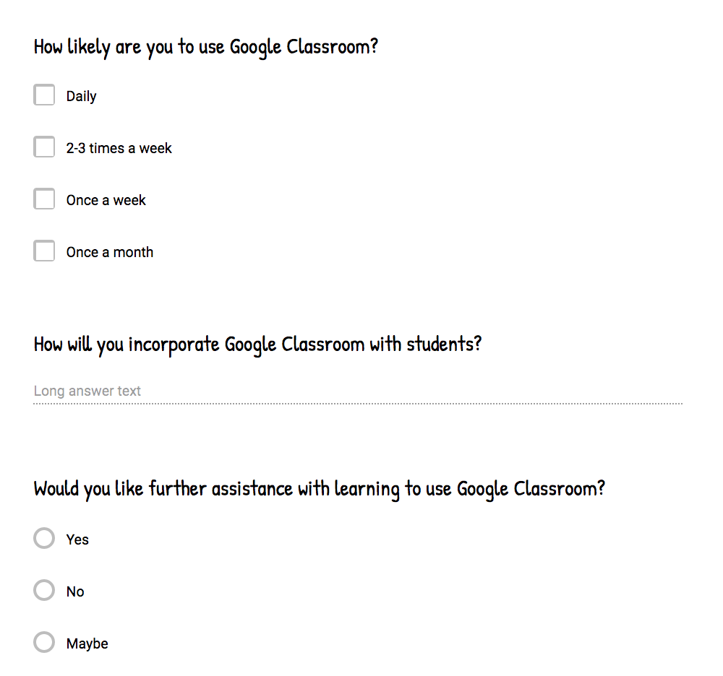

Appendix F
Workshop 2: Google Classroom Survey Results

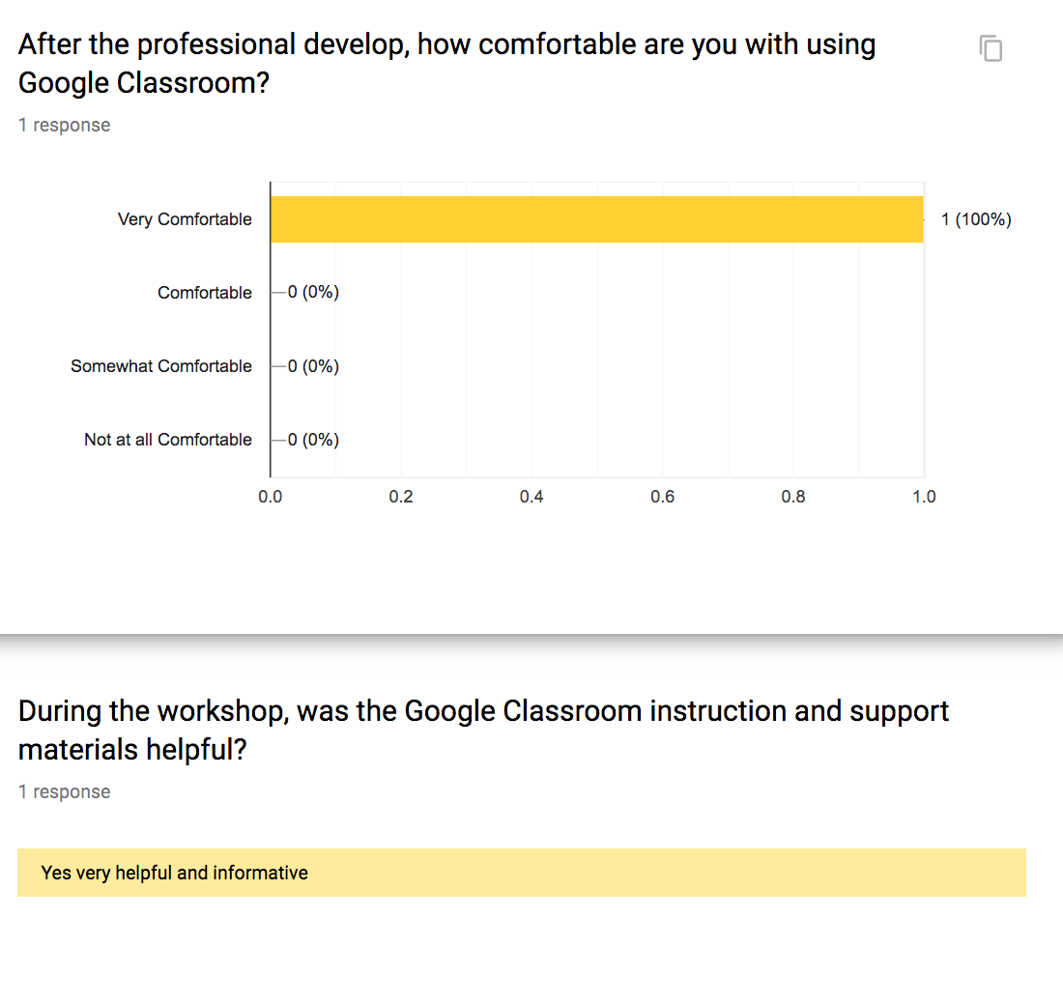
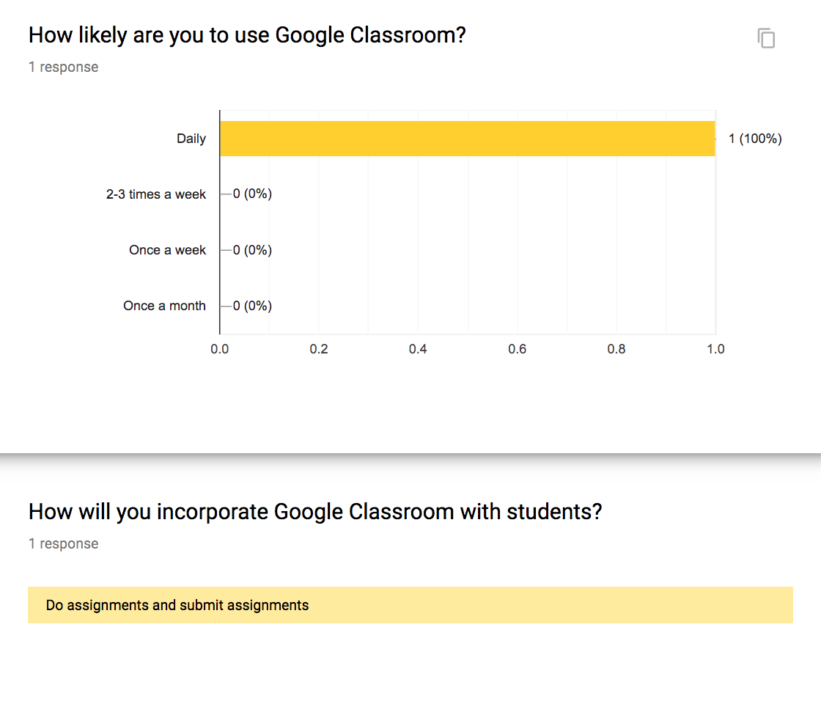
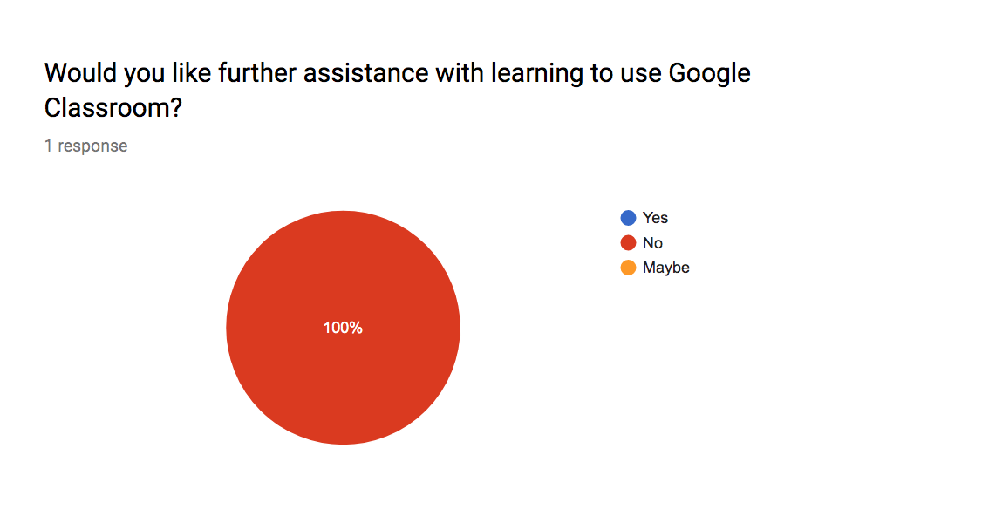

Appendix G
Workshop 3: Google Slides Survey

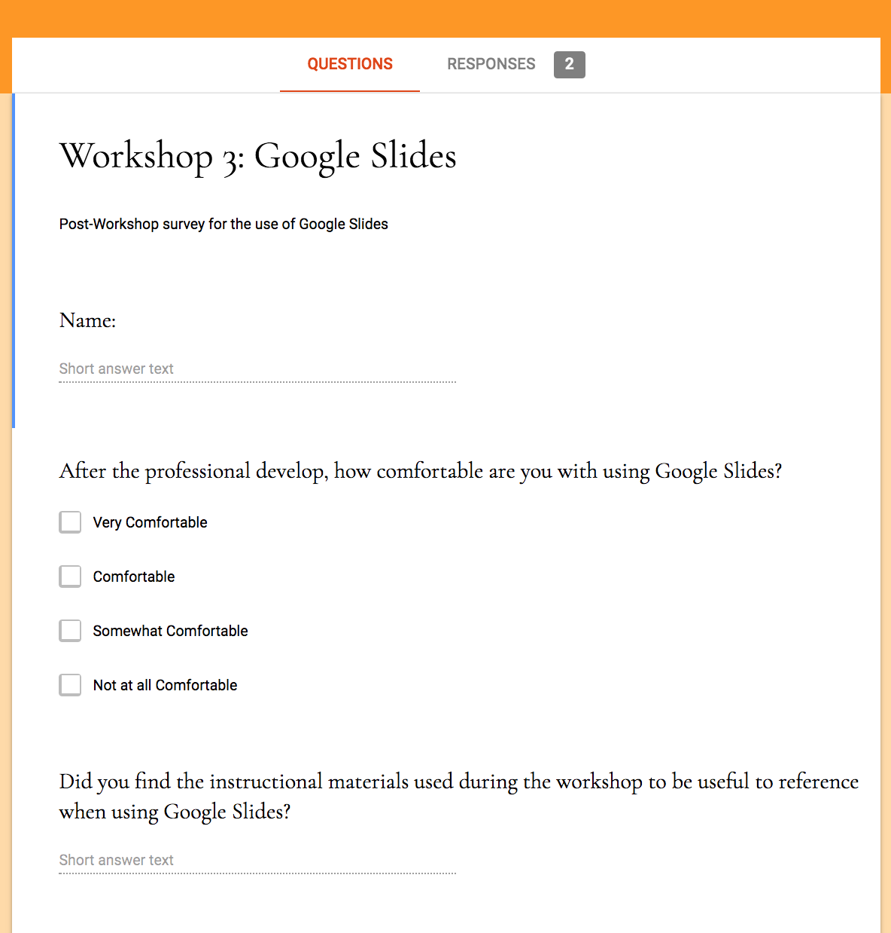
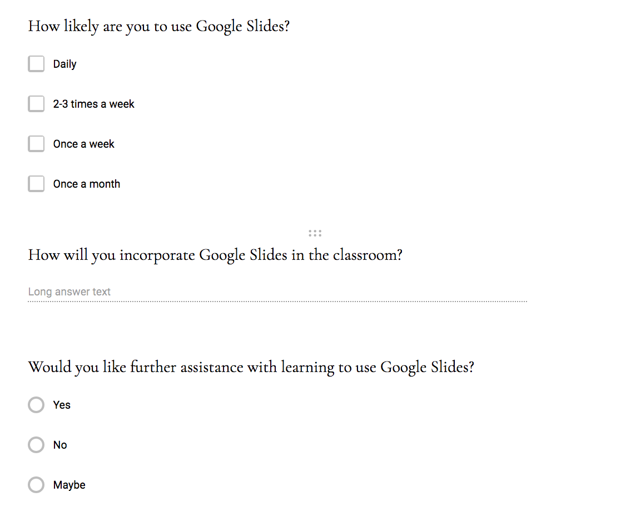

Appendix H
Workshop 3: Google Slides Survey Results

